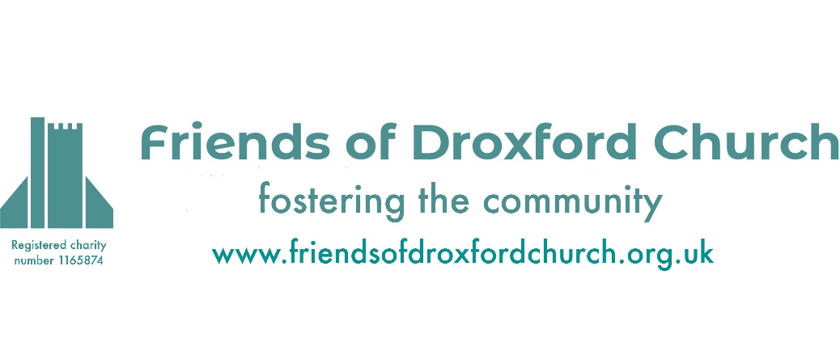
AGM Agenda
Monday 17th February 2025
6.30pm in Droxford Church

Agenda and reports are available on our website: www.friendsofdroxfordchurch.org.uk

- Welcome and Apologies.
- Approval of the Minutes of the 2024 AGM.
- Chairman’s Report – available from our website.
- Treasurer’s Report – available from our website.
- Changes to and Election of Trustees – Tony Hoile and June Kershaw are retiring by rotation. Both being eligible and offer themselves for re-election. Adam Sinnott and Paul Cooper have been appointed as Trustees since the last AGM. With regret John-Dryden-Brownlee passed away since the last AGM.
- Presentation on the Role of FODC by Sally Sturt.
- Presentation by Adam Sinnott on “How Riotous Droxford helped shape the world”.
- AOB.

Sally Sturt (Secretary)

